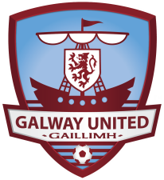
2016 SEASON TICKET APPLICATION FORM
(Season tickets are applicable to all Airtricity League Premier Division Home Matches)

Please Select Type of Ticket
CATEGORY | Normal Price | Early Bird (valid to  24th Dec 2015) | QTY
Adult | €160 | €150
2nd Level Student  (Aged 12 to under 18 Yrs – I.D. required) | €60 | Includes Free Scarf or Hat
Under 12  (Proof of age I.D. required) | €25 | Includes Free Scarf or Hat
Concession  (3rd Level Students/Retired/Unwaged - I.D. required) | €110 | €100
Family  (Two adults, Three children under the age of 18) | €320 | €300

Total Payment |  | €
Cheque | Please make cheques payable to Galway United FC.
Card | Payments can be made using laser or credit card. Phone us on 091-752762 with your card details.
CONTACT DETAILS
Name
Address
E-mail
Contact Phone No

From time to time Galway United FC may email news of the club or special offers that may be available to season ticket holders. If you do not wish to receive emails from Galway United FC please tick this box. (Galway United FC will not pass your information on to third parties)

Further details available from:
E-mail | info@galwayunitedfc.ie |  | Web |  | www.galwayunitedfc.ie
Phone | 091- 752762 Mobile: (086) 3301907
Postal | Galway United FC
 | Eamonn Deacy Park, Dyke Road, Galway
Seller Name |  |  |  | Ticket No

